LAB 4: Detect Malware Capabilities with YARA

- YARA is a popular tool that provides a robust language.

- It is used to examine the suspected files/directories and match strings as is defined in the YARA rules with the file. Install YARA

sudo apt-get install yara 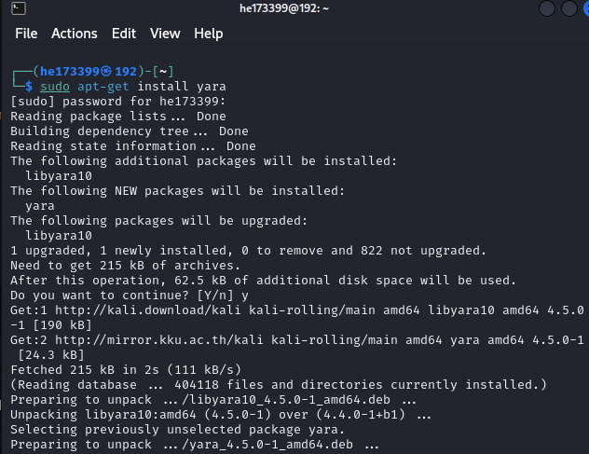

Download package.01.ful.7z:

sudo apt-get install p7zip-full

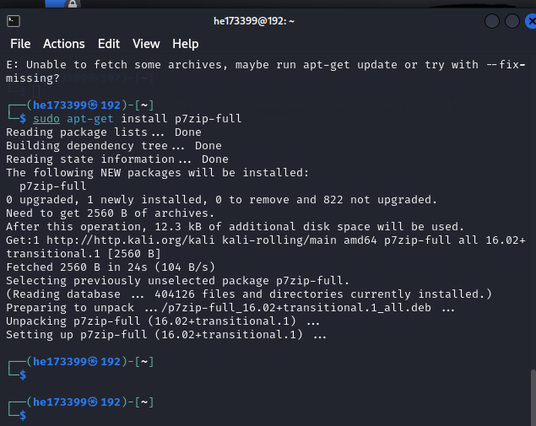

<https://code.google.com/archive/p/clamsrch/downloads>

ls

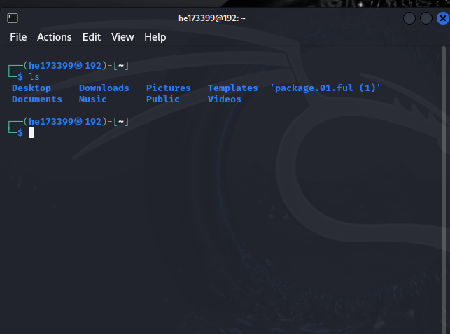

sudo wget <https://github.com/mattulm/volgui/blob/master/tools/clamav_to_yara.py>

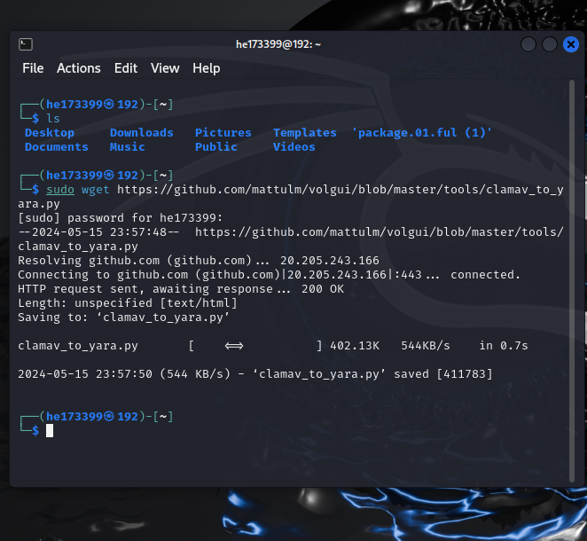

install python2

sudo apt-get install python2

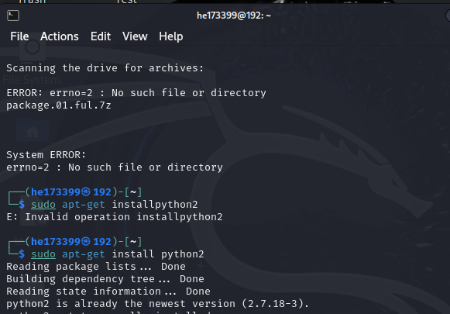

sudo python2 clamav_to_yara.py -f clamsrch.ndb -o clamsrch.yara

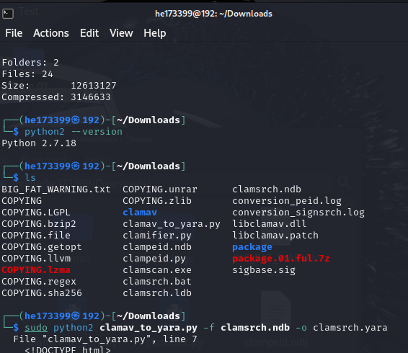

yara -r clamsrch.yara /home/he173399/Downloads/

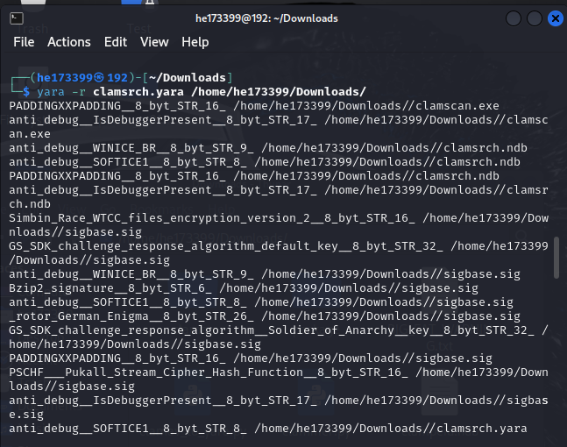

Test yara rules:

yara -r custome.yara /home/he173399/Downloads/

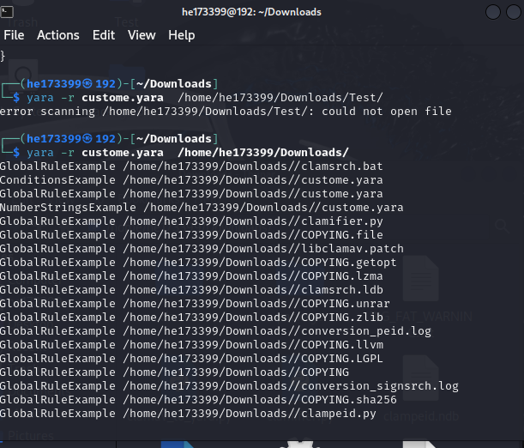

Create a new rule file called custome.yara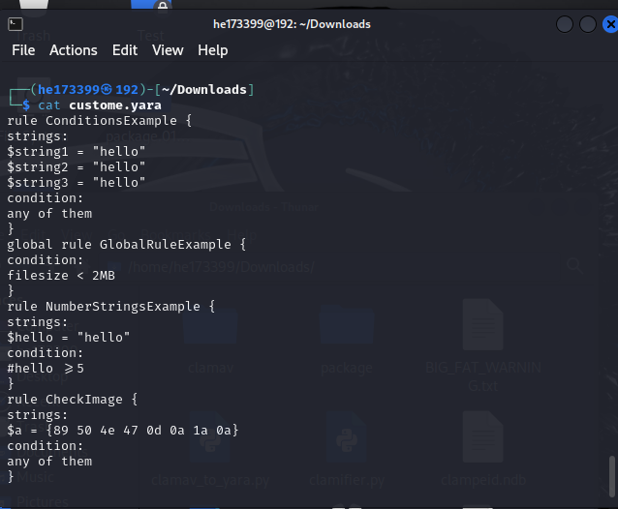

Test yara rules:

